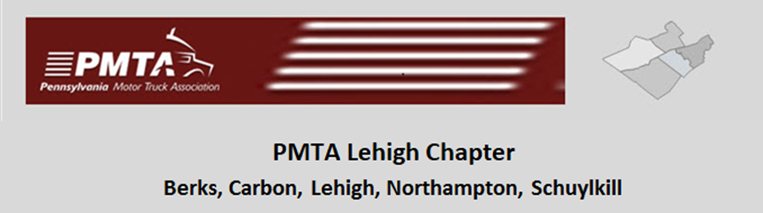

L.V. IRON PIGS BASEBALL GAME

Thursday NIGHT GAME

LOCATION: COCA-COLA PARK, ALLENTOWN, PA

DATE: JUNE 15TH, 2023

COST: $40.00 per person

PEN-TELE-DATA PARTY PORCH

THIRD BASE SIDE

COME OUT AND SUPPORT OUR LOCAL BASEBALL TEAM IN GREAT SEATS

**TICKET PRICE INCLUDES GAME TICKET, 2 ½ HOURS OF ALL YOU CAN EAT BUFFET AND DRINKS (NON-ALCOHOL BEVERAGES). ALCOHOLIC BEVERAGE AVAILABLE FOR PURCHASE**

**CONTACT Dave Rubright at** [**rubrightd@ptd.net**](mailto:rubrightd@ptd.net) **for reservations or further information.**

**Order Tickets early. Tickets will be emailed to the name of the person making reservations. When ordering tickets please include your e-mail address!!!**

**Reservation Deadline: Friday June 09, 2023 - all tickets must be paid for prior to the game. Send payment to LV Chapter PMTA, P.O. Box 325 Fogelsville, PA 18051-0325**