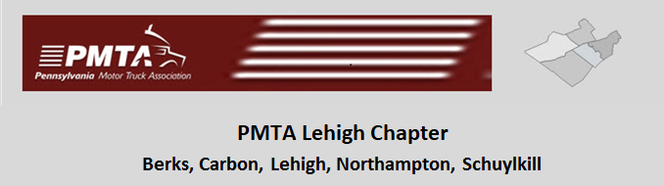

Pennsylvania Motor Truck Association

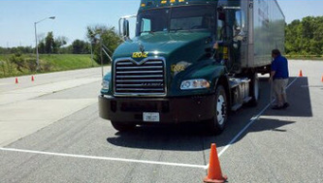
Lehigh Valley Truck Driving Championships "Tune-up" Drive

Scholarship
2021
INTRODUCTION

In 2013, the Board of Directors of the Lehigh Chapter of the Pennsylvania Motor Truck Association voted to start a scholarship program for family members of employees of companies who are members, in good standing, of the chapter. For the calendar year 2021, the board has authorized awarding up to three $1000.00 scholarships to individuals meeting the eligibility criteria and guidelines described below. The award per individual is (1) $1,000. Existing participants and new applicants must apply each year. High school students in their senior year, those individuals presently employed by member companies are invited to apply and individuals currently enrolled in related programs.

MISSION STATEMENT

The Lehigh Chapter of the Pennsylvania Motor Truck Association wishes to advance the educational opportunities of family members of those individuals who are employed by companies which are members in good standing of the Chapter.

ELIGIBILITY

Scholarships are available to the following students and individuals:

- Those who are members and family members of existing employees of companies, who are members of the Lehigh Chapter of the Pennsylvania Motor Truck Association in good standing. Family members are defined as spouses, children, step children, grandchildren and of those employees.

- Preference will be shown to those applicants who intend to pursue trucking industry related studies by taking college courses, trade school courses, or vocational training focused on the following:
  - Trucking
  - Logistics
  - Driver Training
  - Repair and Maintenance of Commercial Vehicles
  - Other industry related activities
  - Applications for non-industry related studies are welcome and will receive careful review.

- Applicants should be able to demonstrate that within the current restrictions of his/her present course of study, they are making a personal effort to earn part of the cost of their education.

- Name and address of school you will be attending.
GUIDELINES

Below is a list of guidelines that the Lehigh Chapter applicants need to follow:

- Applications will be accepted during January 1, 2021 thru May 15, 2021. Successful recipients will be notified at an annual event at the discretion of the Board

- Applicants will be asked to furnish transcripts and employment history.

- Applicants are required to obtain a personal recommendation from a source of their choice.

- Applicants are required to write and submit an essay of between 300 and 500 words detailing their career goals, extracurricular activities, and why that applicant should receive the scholarship. Applicants should demonstrate how their proposed course of studies relates to the trucking industry.

- Checks will be made payable to and sent to the Institution Students are enrolled.

  - You must provide the name of the School you are will be attending.
  - You must provide the address of the School you will be attending.
  - You must provide the name or office check must be sent to.

